**Exercise 1: Configuring a Basic Spring Application**

**LibraryApp.java**

package com.library.main;

import org.springframework.context.ApplicationContext;

import org.springframework.context.support.ClassPathXmlApplicationContext;

import com.library.service.BookService;

public class LibraryApp {

public static void main(String[] args) {

ApplicationContext context = new ClassPathXmlApplicationContext("applicationContext.xml");

BookService bookService = (BookService) context.getBean("bookService");

bookService.addBook("One Hundred Years of Solitude");

((ClassPathXmlApplicationContext) context).close();

}

}

**BookRepository.java**

package com.library.repository;

public class BookRepository {

public void saveBook(String bookName) {

System.***out***.println("Bookname: '" + bookName + "' saved to repository.");

}

}

**BookService.java**

package com.library.service;

import com.library.repository.BookRepository;

public class BookService {

private BookRepository bookRepository;

public void setBookRepository(BookRepository bookRepository) {

this.bookRepository = bookRepository;

}

public void addBook(String bookName) {

System.***out***.println("Add the book: " + bookName);

bookRepository.saveBook(bookName);

}

}

Output:

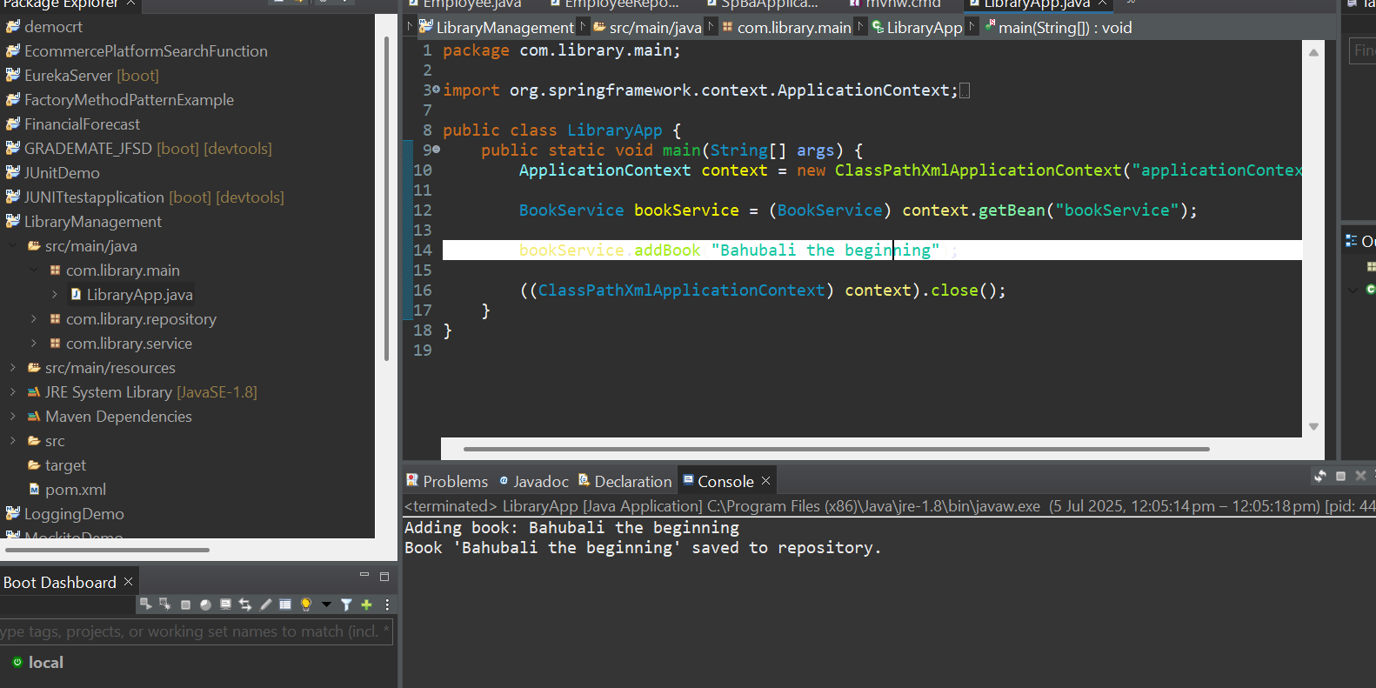

**Exercise 2: Implementing Dependency Injection**

**BookService.java**

package com.library.service;

import com.library.repository.BookRepository;

public class BookService {

private BookRepository bookRepository;

public void setBookRepository(BookRepository bookRepository) {

this.bookRepository = bookRepository;

}

public void printBooks() {

System.***out***.println("Books in Library: " + bookRepository.findAllBooks());

}

}

**BookRepository.java**

package com.library.repository;

import java.util.Arrays;

import java.util.List;

public class BookRepository {

public List<String> findAllBooks() {

return Arrays.*asList*("The Alchemist", "To Kill a Mockingbird", "Bahubali the beginning");

}

}

**LibraryManagementApplication.java**

package com.library.main;

import org.springframework.context.ApplicationContext;

import org.springframework.context.support.ClassPathXmlApplicationContext;

import com.library.service.BookService;

public class LibraryManagementApplication {

public static void main(String[] args) {

ApplicationContext context = new ClassPathXmlApplicationContext("applicationContext.xml");

BookService bookService = (BookService) context.getBean("bookService");

bookService.printBooks();

}

}

Output:

**Exercise 4: Creating and Configuring a Maven Project**

**BookService.java**

package com.library.service;

import com.library.repository.BookRepository;

public class BookService {

private BookRepository bookRepository;

public void setBookRepository(BookRepository bookRepository) {

this.bookRepository = bookRepository;

}

public void printBooks() {

System.***out***.println("Books in Library: " + bookRepository.findAllBooks());

}

}

**BookRepository.java**

package com.library.repository;

import java.util.Arrays;

import java.util.List;

public class BookRepository {

public List<String> findAllBooks() {

return Arrays.*asList*("The Alchemist", "To Kill a Mockingbird", "Bahubali the beginning");

}

}

**LibraryManagementApplication.java**

package com.library.main;

import org.springframework.context.ApplicationContext;

import org.springframework.context.support.ClassPathXmlApplicationContext;

import com.library.service.BookService;

public class LibraryManagementApplication {

public static void main(String[] args) {

ApplicationContext context = new ClassPathXmlApplicationContext("applicationContext.xml");

BookService bookService = (BookService) context.getBean("bookService");

bookService.printBooks();

}

}

**Pom.xml**

<project xmlns="http://maven.apache.org/POM/4.0.0"

xmlns:xsi="http://www.w3.org/2001/XMLSchema-instance"

xsi:schemaLocation="http://maven.apache.org/POM/4.0.0

http://maven.apache.org/xsd/maven-4.0.0.xsd">

<modelVersion>4.0.0</modelVersion>

<groupId>com.library</groupId>

<artifactId>LibraryManagement</artifactId>

<version>1.0-SNAPSHOT</version>

<properties>

<maven.compiler.source>1.8</maven.compiler.source>

<maven.compiler.target>1.8</maven.compiler.target>

</properties>

<dependencies>

<!-- Spring Context -->

<dependency>

<groupId>org.springframework</groupId>

<artifactId>spring-context</artifactId>

<version>5.3.33</version>

</dependency>

<!-- Spring AOP -->

<dependency>

<groupId>org.springframework</groupId>

<artifactId>spring-aop</artifactId>

<version>5.3.33</version>

</dependency>

<!-- Spring WebMVC -->

<dependency>

<groupId>org.springframework</groupId>

<artifactId>spring-webmvc</artifactId>

<version>5.3.33</version

</dependency>

</dependencies>

<build>

<plugins>

<plugin>

<groupId>org.apache.maven.plugins</groupId>

<artifactId>maven-compiler-plugin</artifactId>

<version>3.8.1</version>

<configuration>

<source>1.8</source>

<target>1.8</target>

</configuration>

</plugin>

</plugins>

</build>

</project>

Output:

